

SUMMARY OF QUALIFICATIONS

- Over 10 years of experience in Automotive electronic engineering
- Experience of developing Electrical products from concept to production
- Experience to work with remote/international teams
- Knowledge of Agile (Scrum/Kanban)
- Proven skills in project management
-Risk management
-Cost management
-Customer management
-Reporting (internal/external)
- Project tracking
- Excellent communication/interpersonal skills, with strong influencing and engagement skills
- Experience with problem solving techniques (e.g., six-sigma)
- Experience with JIRA, Doors and Confluence – Requirements/issues management tools
- Experience with working with overseas teams
- Computer skills include: - MS Office
- AUTOCAD, UG
- JIRA, Doors, Confluence
- Automotive diagnostic tools
[ Canoe, Vehicle Spy, ODIS]

EDUCATION

MSc Automation & Control - Master degree 2010.8 - 2011.11
University of Newcastle (UK)
Electrical and Electronic Engineering - Undergraduate degree 2006.9 - 2010.6
University of Bradford (UK)
Foundation Engineering Course 2005.8 - 2006.7
INTI International University College, (Malaysia)

PROFESSIONAL EXPERIENCE
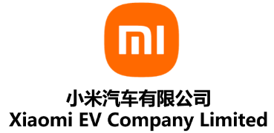
Company: XiaoMi EVcar Company
Duration: 2021.11 – Now
Position: PM for Feature delivery
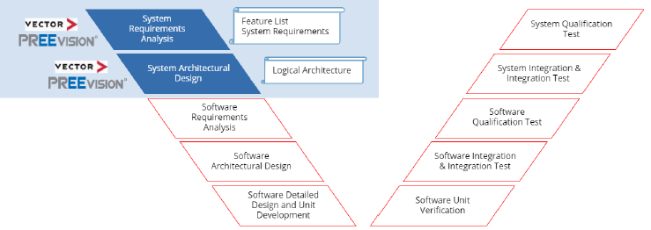

Main responsibility:
- Collect the Product Requirement Document (PRD) for area of (ADAS/ Intelligent Cockpit/Propulsion/Climate/Handling/Motion).
- Complete the Electrical function list according to the Customer requirement.
- Leading the definition of use case and implementation methods of ADAS/Intelligent cockpit/Propulsion/Climate/Handling/Motion functions
- Trace the deliverables state for System Requirement Analysis/ System Architectural Design/ Software Requirement Analysis/ Test results (Integration in Bench and Vehicle)
- Work with the Application software team and ECU Owner (DRE), deliver corresponding EE functions in proper baseline.


Company: SAIC Motor Z-ONE Software Company
Duration: 2021.3 – 2021.11
Position: PM for Feature delivery
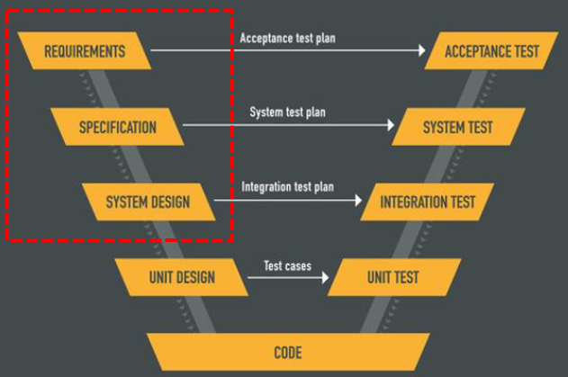
Main responsibility:
- Collect the Product Requirement Document (PRD) for ADAS / Intelligent cockpit/Propulsion/Climate/Handling/Motion from Customer (New brand called IM Car)
- Complete the EE function list according to the PRD.
- Leading the definition of scenarios and implementation methods of intelligent cockpit functions based on function lists.
- Trace the deliverables state for Function Allocation Spec/ Sub System Technical Spec
- Work with the Application software team and ECU Owner (DRE), deliver corresponding EE functions in proper baseline.


Company: Evergrande New Energy Automotive, Shanghai, China
Duration: 2020.11 – 2021.3
Position: Intelligent cockpit Technical Project Manager (TPM) - Manager
Main responsibility:
- Manage the Project activities (Timing, risk, quality, cost) for all Intelligent cockpit’s modules.
Including: Instrument Cluster Display, Rear Seat Display, Inner Rear-View Mirror, Digital Video Record, Hud, T-Box, Antenna, Switches, Wireless Charing, In-Vehicle-Infotainment (IVI).
- Work with key stakeholders in product management and executive teams to define strategy and requirements.
- Work with remote teams to deliver supporting software and hardware in sync with launch
timelines. Communicate regularly with senior manager on status, risks and change control.


Company: Jaguar Land Rover Automotive, Shanghai, China
Duration: 2018.8 – 2020.11
Position: Electronic & Electrical Senior Technical Project Manager (TPM)
Main responsibility:
- Manage the Project activities for all Electrical components, working as EE Platform Project Leader, to lead the deliverables and requirements and interface between the Project and engineering teams. Key role to ensure Project focus within engineering team and represent the functional requirements within the Project.
- Understand the needs of the Project and how they relate to Electrical Engineering delivery. Represent Electrical Engineering in all Project activities; identify Project requirements and priorities to the delivery team. Manage the Project status and report out to the Senior Manager & Programme Director.
- As the EE leader within the Project steering team liaising with Programme Director (UK&CHINA), Purchasing, Supplier, Manufacturing, Marketing and Finance, representing the needs of Electrical department and understanding the deliverable requirements of the Project.


Company: Pan Asia Technical Automotive Center, Shanghai, China
Duration: 2015.8 – 2018.8
Position: Cluster Instrument Engineer (DRE/FOP)
Main responsibility:
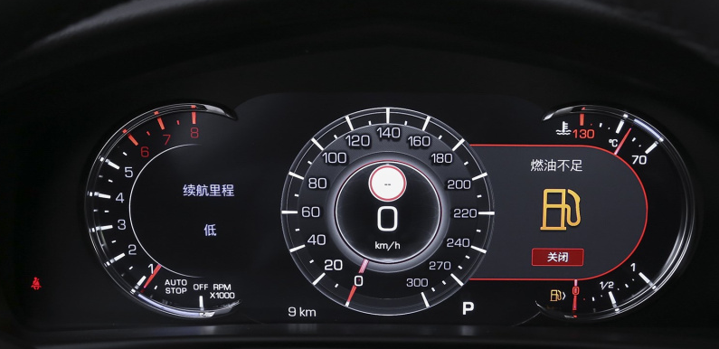
- Manage and coordinate the design, development, testing and introduction of new systems and components
- Manage the components through GVDP (General Motor) processes
- Generates technical solutions for new and major programs
- Ensure components meet the relevant legal regulations & CTS/SSTS requirements
- Manage Change Request and expenditure forecasting
- Resolve issues with component engineering and vehicle attribute teams across all the manufacturing sites
- Supporting the General Motor (USA) team to sign off the components within the systems
- Own and deliver the Engineering APQP deliverables (to complement the APQP deliverables).

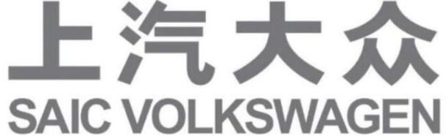
Company: YiRui Automobile Technology (service for Shanghai Volkswagen),
Duration: 2012.1 – 2015.8
Position: Climate Controller Engineer FOP
Main responsibility:
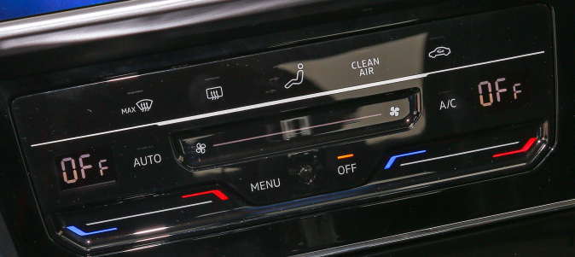
- Compile product definition of climate control panel for supplier nomination.
- Organize time schedule of localization development in aspect of tooling construction, software and hardware, testing and so on to catch SOP milestone.
- Define testing catalog including dimension, material, function, network, optic and EMC tests, etc., and track progress of the validation.
- Implement function testing with diagnoses tools and CANOE on climate controller, climate system (sensors, flap motors and HVAC components) and partial related function of Radio or Navigation, body center controller, start-stop system, etc.
- Lead execution of failure mode analysis happened in validations, searching the solutions and tracking the process of optimization.
- Join in the road test and make assessment of comfortable performance.
- Coordinate with domestic and EU engineers from both OEMs and suppliers to communicate

the project development process.
- Present production risk and plan to program managers.
- Analyze potential technical change of climate system components, execute if feasible, economical and approved.
- Budget and negotiate development cost with suppliers.

